PART ONE: MAKING A WEBSITE FOR YOUR PORTFOLIO ON WEEBLY

- Go to http://students.weebly.com
- Login (your teacher has your username and password)
- Click on “edit site” (see picture below)

- Your website will begin by looking like this (see below)
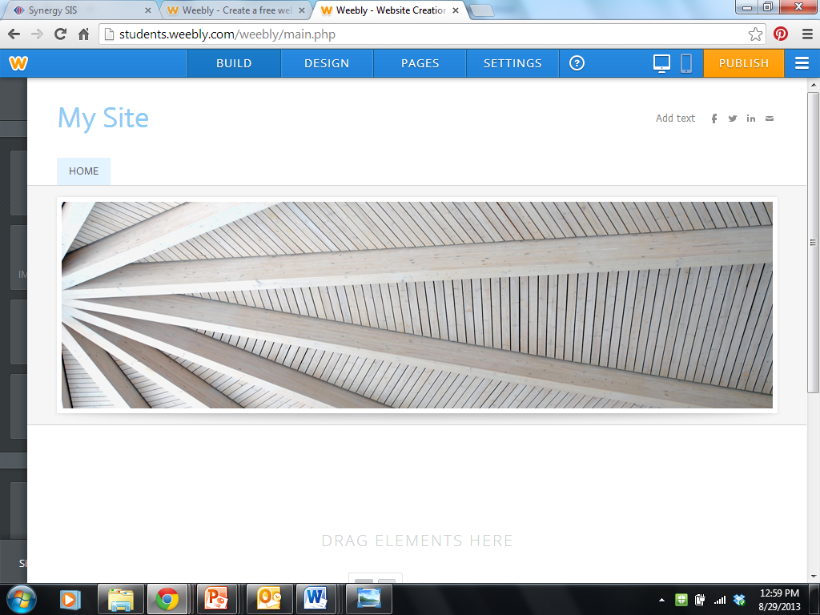

- Change the “My Site” to a name of your choice (make sure it includes your first name!). You can do this by clicking and highlighting “My Site” and typing in your new name (see example below)

- Pick a design theme for your website by clicking on “design” at the top of the page (see example below). You can pick any theme you like. For this example, I am going to keep the same theme.
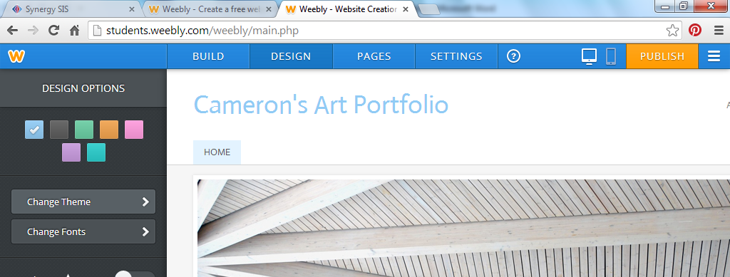

- Change the main image on your website to something that represents you and your ideas/thoughts about Art. You can search the internet and find an image or you can use an image you already have. The image should be appropriate for school and not include images of violence, drug use, cursing, or rude language or dress. To change the image, click on “edit image.” The website will walk you through the process. Once you are done, click “SAVE” at the top right of the screen.
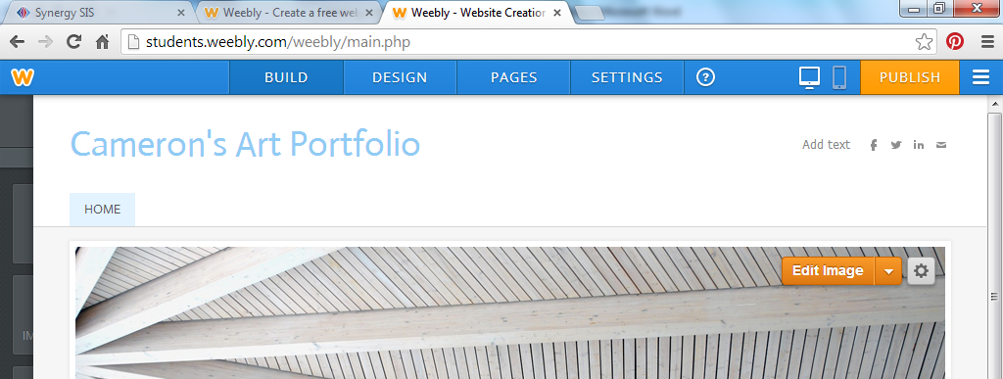
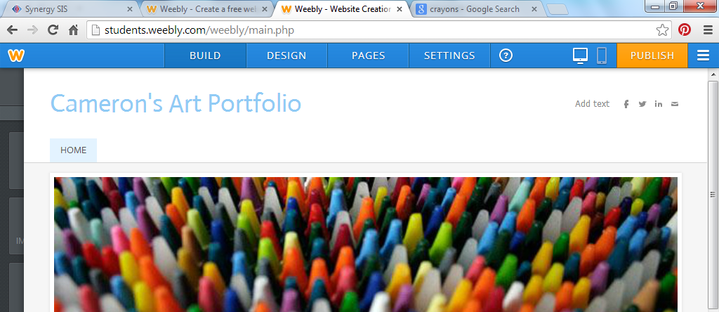

- You are now ready to publish. Click on “Publish” in the top right corner, and your website will go “live” and people can now view it.

PART TWO: MAKING A “MY ART” PAGE FOR YOUR WEBSITE
We will make pages for our websites wherein we will place different assignments. Follow these steps to make your pages.

- Go to http://students.weebly.com
- Login (your teacher has your username and password)
- Click on “edit site” (see picture below)

- Click on “pages” at on the top menu (see example below)

- Click on “Add a Page” and choose “Standard Page”
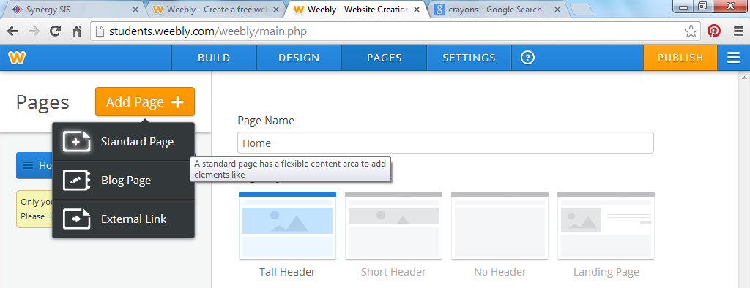
- Title the page “My Art” and then click on “Save and Edit”
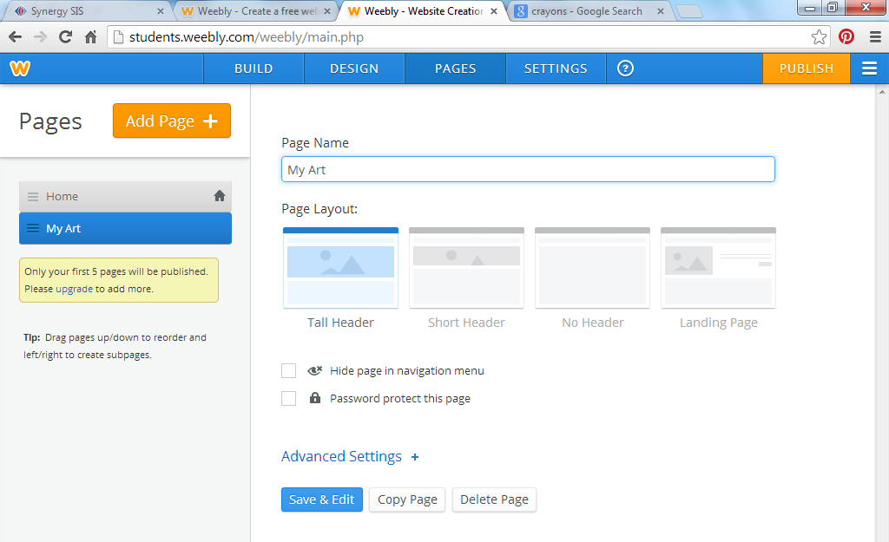

- This is the page where you will upload everything you make in 8th VA COMP this year. You can add pictures to this page by following the next few steps.

- Click on “Image” and drag it over to the part of your screen that reads “drag elements here”
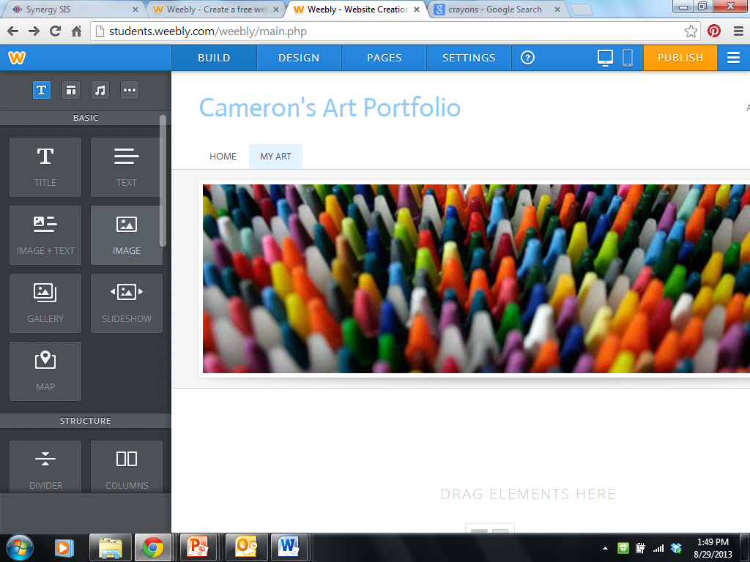

CONTINUED ON NEXT PAGE

- Click on “upload image” and follow the directions to upload an image of your art.
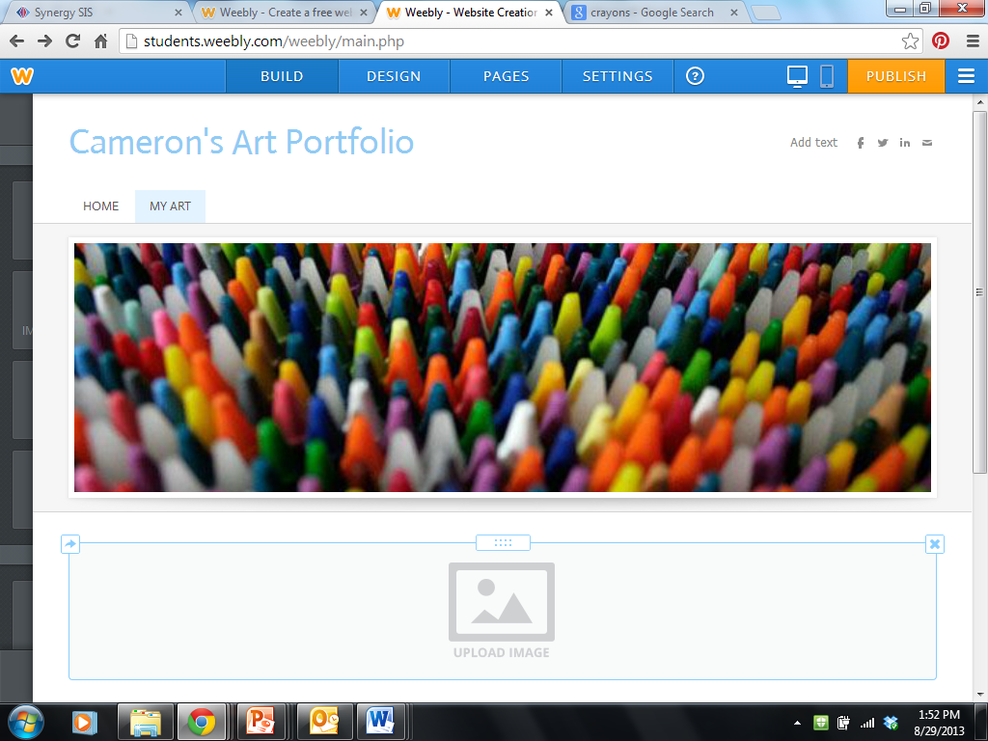

- You can resize the image after you upload it.
- Don’t forget to click “Publish” so your changes will go live!!!

PART THREE: MAKING A PAGE FOR COMMON ASSESSMENTS

- Go to http://students.weebly.com
- Login (your teacher has your username and password)
- Click on “edit site” (see picture below)

- Click on “Add a Page” and choose “Standard Page”

- Title the page “Common Assessments” and choose “Save and Edit”
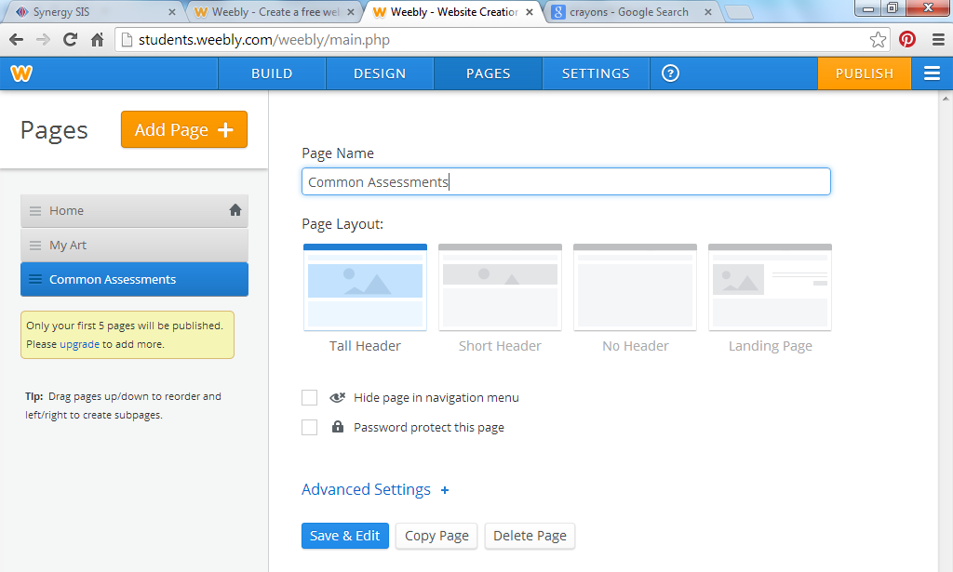

- CLICK PUBLISH TO MAKE SURE YOUR CHANGES GO LIVE!
- This is where we will upload our four common assessment assignments. I will help you do this in class.

YOUR FINISHED WEBSITE SHOULD LOOK SOMETHING LIKE BELOW
